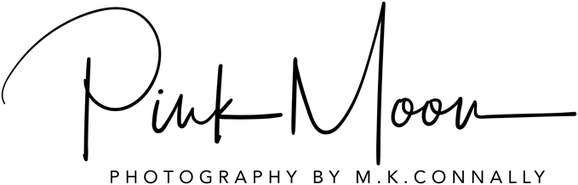

Model Release Form
PHOTOGRAPHER: PINK MOON PHOTOGRAPHY – MARCIE KILLIAN CONNALLY
MODEL: _____________________________________________________________________
MODEL’S EMAIL ADDRESS: ____________________________________________________________
MODEL’S MAILING ADDRESS: ___________________________________________________________
IN CONSIDERATION OF HAVING RECEIVED (i.e. Photos/Compensation/etc) _______________________
IN RETURN FOR POSING FOR PHOTOGRAPHS TAKEN ON (date): ________________________________
AT (location): _____________________________________________________________
I hereby assign full copyright of these photographs to the above-mentioned photographer (and the related representatives and assigns) together with the right of reproduction either wholly or in part.
I grant to the Photographer or licensees or assignees the permission to use the above-mentioned photographs either separately or together, either wholly or in part, the perpetual, irrevocable and unrestricted right to use photographs of me, where I may be included for editorial trade, product advertising and such other fashion /business purpose in any manner and medium.
The Photographer and licensees or assignees may have unrestricted use of these for whatever purpose, including advertising, with any retouching or alteration without restriction.
I agree that the above mentioned photographs and any reproductions shall be deemed to represent an imaginary person, and further agree that the Photographer or any person authorized by or acting on his or her behalf may use the above mentioned photographs or any reproductions of them for any advertising purposes or for the purpose of illustrating any wording, and agree that no such wording shall be considered to be attributed to me personally unless my name is used.
Provided my name is not mentioned in connection with any other statement or wording which may be attributed to me personally, I undertake not to Prosecute or to institute proceedings, claims or demands against either the Photographer or her agents in respect of any usage of the above mentioned photographs. I hereby release the photographer named above from all claims and liability relating to images, video or photographs taken of me.
I have read this model release form carefully and fully understand its meanings and implications.

signed: _______________________________ date: __________
Important: If the Model is under 18 year of age, a parent or legal guardian must also sign

parent/guardian: _______________________ date: __________

